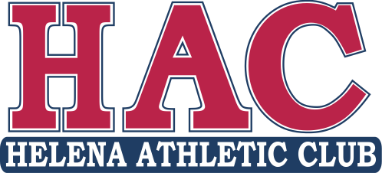Summer Camp Director

Position Description

Helena Athletic Club is hiring a creative and organized director to plan, prepare and implement an enriching, comprehensive and structured summer camp program. The summer season at HAC is 11 weeks of full day, week-long camps. The director is supported by a full staff and administration manager. The director will work between 20-35 hours per week depending on self-scheduling and program needs.

Responsibilities

* Plan daily schedule, activities, field trips (1-2x per week) for 11 weeks of camp
* Create lesson plans, material lists for weekly camps
* Effectively communicate lesson plans, schedules, etc. to schedule staff
* Create organized communication to staff and parents

Requirements

* 3+ year’s experience in school-aged youth program in sport, daycare or classroom/school setting
* Strong interpersonal, planning and organization skills
* Strong written communication ability
* Education degree or another early-ed certificate
* Passionate and enthusiastic interactive and management abilities

Benefits

* Part-time position with competitive wage ($18+/hour)
* Flexible, self-directed/determined schedule within Monday-Friday, 7:30-5:30
* Some work-from-home capability
* Discounted tuition for family members in gym programs
* Other benefits (supplemental insurance, etc. available after one year employment)
* Fun, positive, exciting, collaborative, family-oriented and well-supported environment

Application Details

* Position closes February 22nd
* Submit cover letter and resume to office@hacmt.com
* Paid prep and planning begin May 1, camps begin June 9